**ENSE 374 - Interactive map of Canada**

**Team Members:**

● Hasaan Toor

● Lalith Souri

● Rizwan islam

**Project Sponsor:**

● Dr. Timothy Maciag

### **Project background/Business Opportunity:**

This interactive map will be based on the Model-View-Controller design architecture. Our reason for making such a project is to aim to help the average user gain information about Canada. One potential use of our map is for travellers to decide where to go within Canada, similarly to how it is difficult to decide on something to watch when having a movie night, it could be difficult to choose a holiday destination within Canada that values the user's money and time. Essentially, our project's main goal is to provide the average user with new useful information that could potentially aid their studies, career, decisions, and more.

**Goals of the project:**

The project will aim to be useful for a variety of business needs. Travel agencies that help newcomers, travellers, tourists, etc that are visiting or moving to Canada can make use of our project as it will provide information that any traveller would require. As this map will provide climate information and information about some of the most successful industries (mining, agriculture, chemical, etc.) in each province, both employers and potential employees can decide where to advance their professional careers. It will also benefit researchers to get high quality and quantity of data from all across Canada, which will help them in whatever they may be researching.

So far we are able to build a map which will help the traveller to set their destination. We also created a comment box so that they can post their comment about the places. This will help the travel agency to find out which spot attracts the tourist most. Also, researchers can gather information from here.

### **Scrum comments & colleague comments:**

#### **Overall feedback (Vida Pathan):**

I really liked the idea of the project, interactive map is a fun way to get more information about a Province. I believe that is what we want for Canada. I myself a travel blogger, I like

to wander more and I am really looking forward to explore more places in Canada and I hope I find the hidden Gems

#### **Overall feedback (Nathan Cameron):**

The idea seems very interesting and useful for many people. I know you focus on the tourist but you could look into educational aspects for something like a elementary school social/geography class as well! I really like the idea and hope that you get a couple MVP's done so I can see how turns out!

#### **Overall feedback (Shahzil Siddiqui):**

I think that you guys have progressed adequately, seems to me that you have covered all required aspects of the three activities that we have explored thus far. It was impressive that you choose to do both the low and high-fidelity prototyping. This will truly help you when designing the actual software interactions as you've already gotten a taste of it. Vlogs are informative and I found GitHub to be very well-organized and easy to navigate. Also, appreciate that you guys separated your .docx and pdf files. Thus, good progress so far.

**Other feedback as the individual feels/warrants:**

* Maybe as part of a future MVP have an actual map of Canada and be able to click on each province, which renders an interactive provincial map that users can hover over for information, like hovering over Regina vs Saskatoon. I just really liked your initial map and hovering idea!
* You might want to consider the filtering aspect of your software on the sign-up page where you can let them choose what kind of user they are. For example, are they travelers, newcomers, tourists, etc. You must have seen this sort of filtering if you have subscribed to online magazines or news channels where they prompt you to pick topics that interest you like sports, technology, politics, etc. This way you can render specific facts and info for your users as they interact from province to province. It would be super cool to also add a "historical" option on the sign-up page too if you end up considering filtering through the sign-up page. Then you can have each province show major historical events that occurred in our provinces. All this might be too much for the initial MVP, however, just things to consider as part of a future update.
* Lastly, I love your main idea, I think it is very unique and can be used in a variety of forms, like in schools or for future citizens and tourists which just adds more value to the scope and impact of your project. Well done with the topic selection!

**Tim's notes:**

OK presentation. Always start with a brief blurb about what you are doing. I think you can get rid of the contact us. You have some work to do and I think and I think you need to focus. My advice. Focus on one thing (food, sports, etc.) per region and dive into some CRUD activities for the community (e.g. enable folks to add info or edit info about sports/food/whatever)

**Impact of the feedback:**

We build an option for contacting us, but lately, we decided to get rid of that. We tried to make a comment box for all the users so that they can post their comments about the places. Also, we tried to make the user interface simple so that it will be friendly for all users. We only focused on the tourist spot for now. Also tried to give some basic information about the provinces to the user.

**Team's exploration:**

We learn how to build the RACI chart for the project and also learn how we can focus on time management. Besides that, we explored some of the front-end and back-end things and tried to implement that in this project. We also explored the hi-fi and low-fi prototypes. Which help us to get comments from our colleague. As this project is based on model-view-controller, we were able to explore some things like NodeJS, JavaScript, and MongoDB.

**MVP Evolution:**

The UML diagram shows how a user can log in to the system. First of all a new user have to create an account on this website after that user is able to log in to this site. After that, they get some cards with the province's name. If they pick any province then it will show them the basic information about that province and also give them some options so that they can choose the Tourist spot they want to visit, it also gives them the option to leave their comment there. And this will help other users to choose their destination.

**Screenshots of the project:**

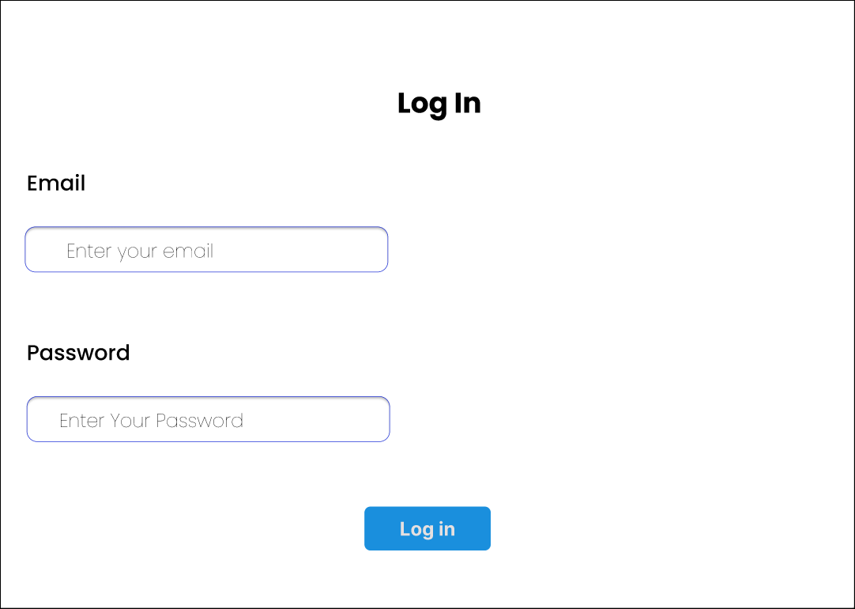

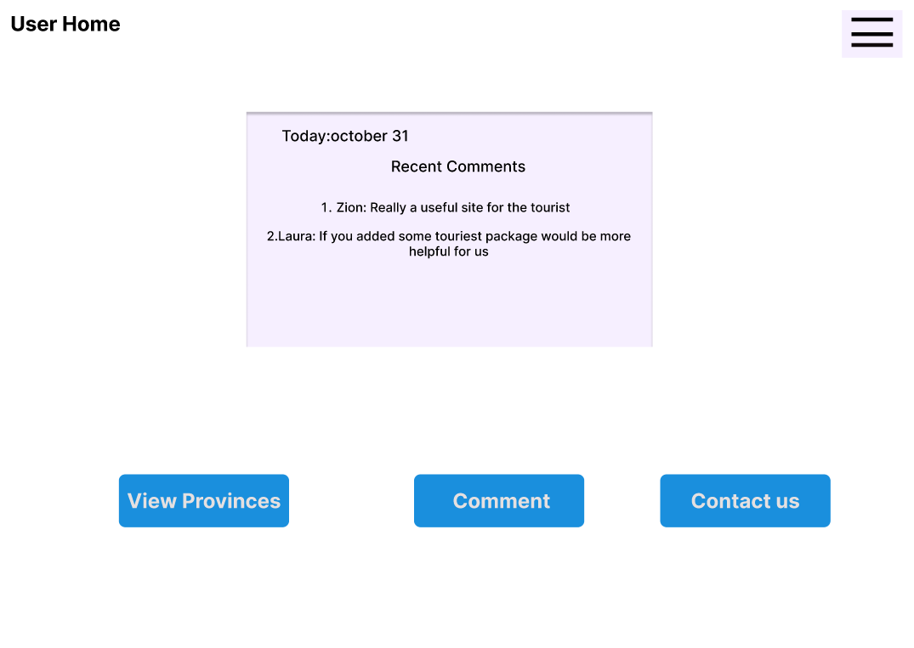

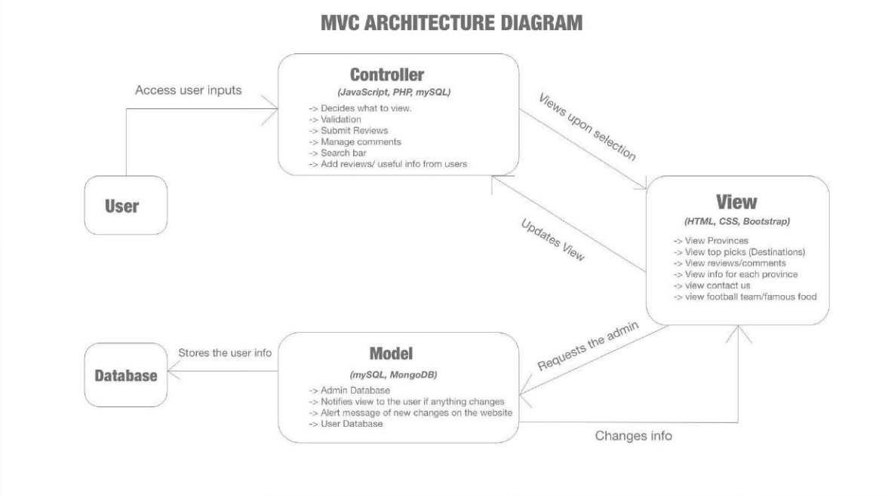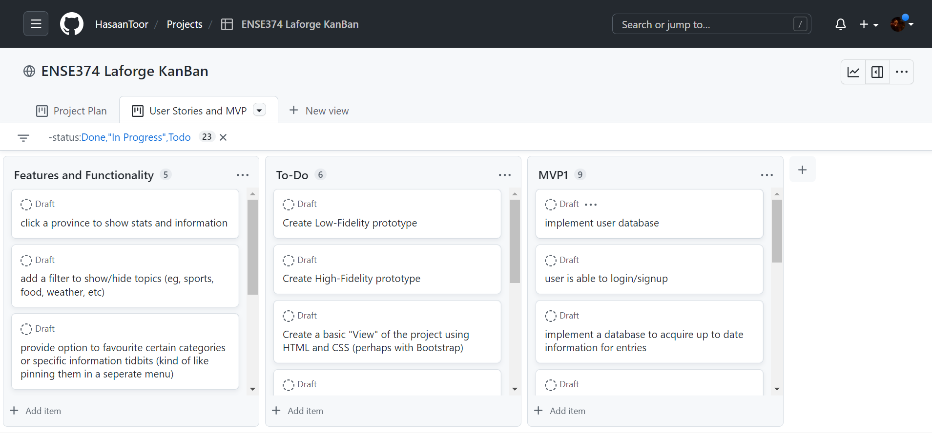

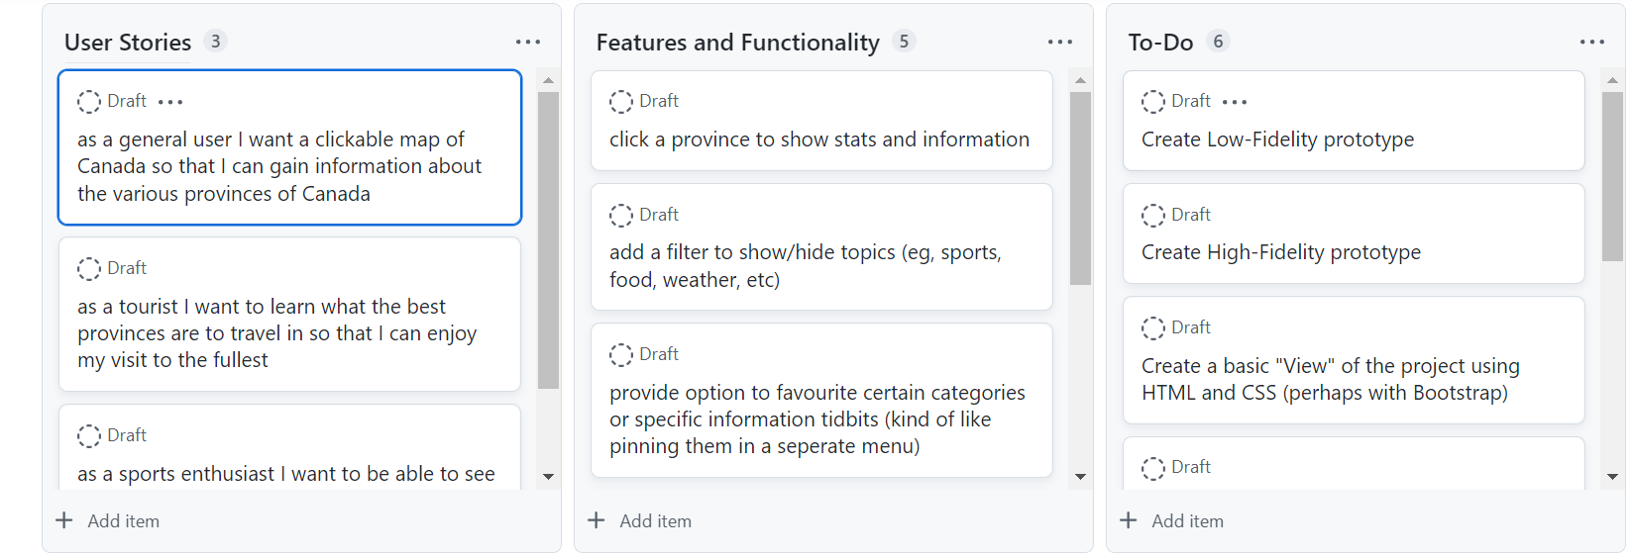

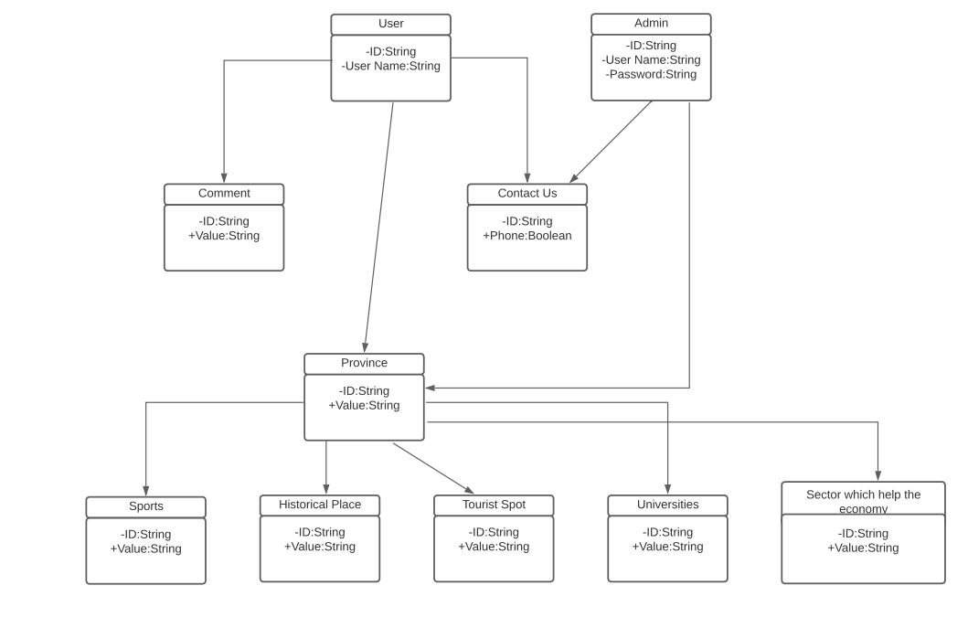

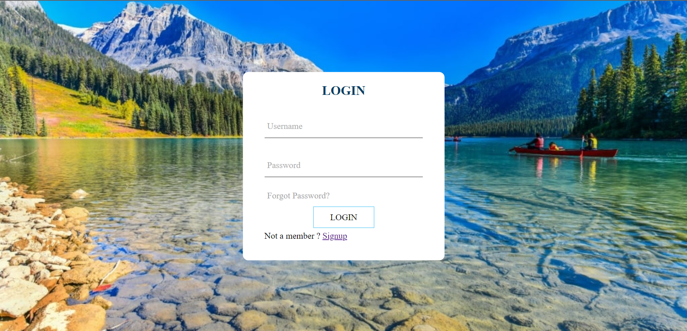

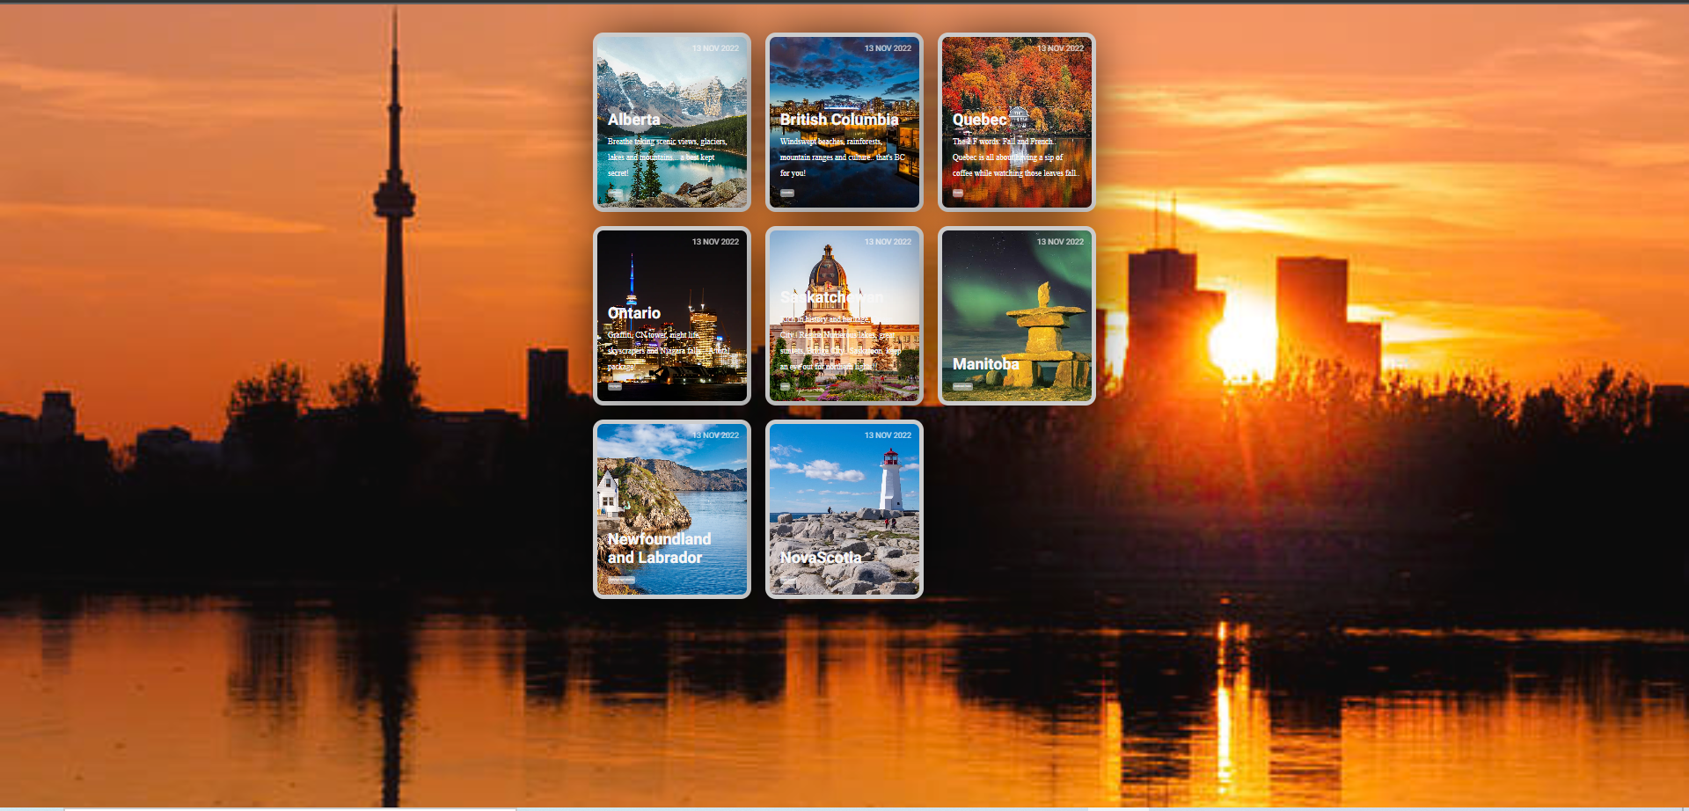

**Reflection on Results:**

We really enjoyed building the project. It was something that none of us had really

done before. There were lots of confusion, and finally, we were able to learn a lot of things through this activity one to five. We learn how to manage time and manage the task as a team, which will help us in future. We wanted to build a lot of things inside the provinces, but we realized that it's better to focus on only one thing at a time. And we decided to build the tourist spot. Colleagues' and sponsors' comments helped us to choose the right path. But we also think that we will build all the options like favourite sports, Historical places, and Foods of the provinces in future, so the business opportunity of this project will increase, and it will help the researchers to get more data.